**Hospital Database Design Project Overview**

**EERD**

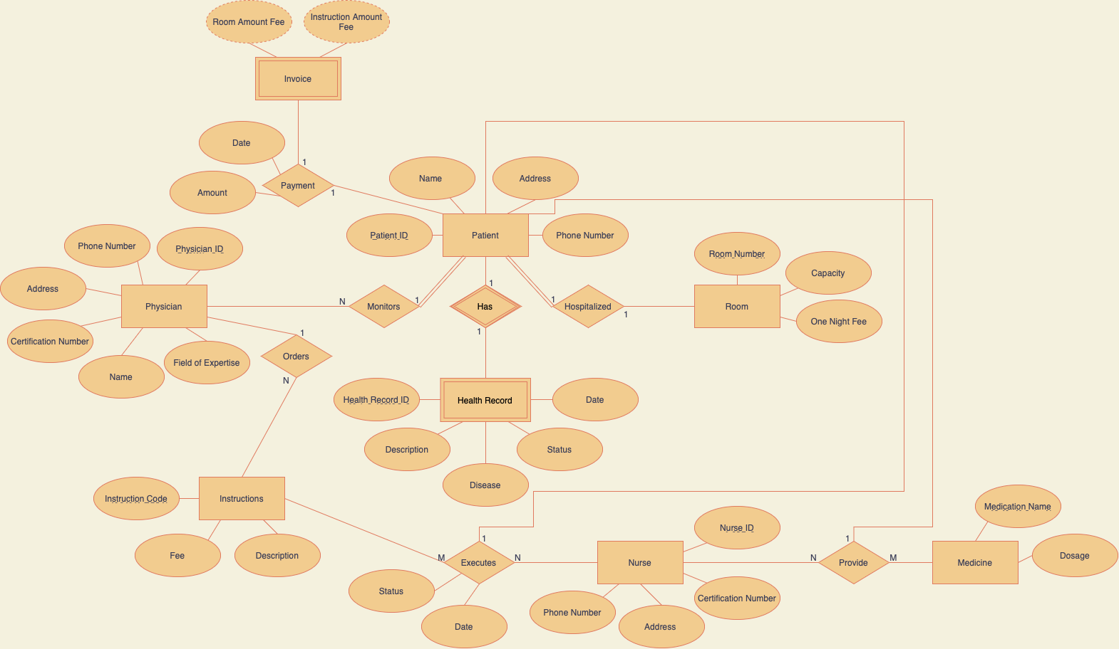

**Set of Relations**

Patient(patient_id, patient_name, address, phone_number, physician_id, room_num)

Primary Key: patient_id

Foreign Key: physician_id references physician(physician_id), room_num references room(room_num)

Room(room_num, capacity, one_night_fee)

Primary Key: room_num

Physician(physician_id, physician_name, certification_number, expertise_field, address, phone_number)

Primary Key: physician_id

Nurse(nurse_id, nurse_name, certification_number, address, phone_number)

Primary Key: nurse_id

Medicine(med_name, dosage, patient_id, nurse_id)

Primary Key: med_name, patient_id

Foriegn Key: patient_id references patient(patient_id), nurse_id references nurse(nurse_id)

Instructions(instruction_code, fee, inst_description, order_date, physician_id, patient_id)

Primary Key: instruction_code

Foreign Key: physician_id references physician(physician_id), patient_id references patient(patient_id)

Execution(instruction_code, patient_id, nurse_id, execution_date, exc_status)

Primary Key: instruction_code, nurse_id

Foreign Key: patient_id references patient(patient_id), nurse_id references nurse(nurse_id)

Invoice(invoice_id, room_fee, instruction_fee, patient_id)

Primary Key: invoice_id

Foreign Key: room_fee references room(one_night_fee), instruction_fee references instructions(fee), patient_id references patient(patient_id)

Payment(payment_id, invoice_id, amount, pay_date)

Primary Key: payment_id

Foreign Key: invoice_id references invoice(invoice_id)

Health_Record(patient_id, rec_date, disease, hrecord_description, pat_status)

Primary Key: patient_id

Foreign Key: patient_id references patient(patient_id)

**Potential VIEWS for Database**

CREATE VIEW med_list AS

SELECT med_name, dosage, nurse_name

FROM medicine INNER JOIN nurse ON medicine.nurse_id = nurse.nurse_id;

Function: The view creates a list of medicines, their dosages, and the nurses in charge of providing those dosages. This view is helpful as it can be used to track which nurses are responsible for which doses of each specific medication.

CREATE VIEW patient_physician AS

SELECT patient_name, physician_name

FROM patient JOIN physician ON patient.physician_id = physician.physician_id;

Function: The view creates a list of patient-physician relations so an individual patient's Doctor can be kept track of. This can be useful to keep track of a patient's physician if they are switched between specialities.

CREATE VIEW invoices_sum_payments AS SELECT invoice_id, SUM(amount) AS sum_payments

FROM payment GROUP BY invoice_id;

SELECT * FROM invoices_sum_payments;

Function: This view lists invoices by their IDs and the sum of the payments made towards the invoices. This view is useful as it can be used to determine the amount patients owe for their medical treatment.

**Potential TRIGGERS for Database**

CREATE TRIGGER nurse_required

BEFORE INSERT ON medicine FOR EACH ROW

BEGIN

IF NEW.nurse_id IS NULL THEN

SIGNAL SQLSTATE '10500' SET MESSAGE_TEXT = 'A nurse is required to add a medication';

END IF;

END;

Function: The trigger ensures that any medicine added to the medicine table has a corresponding nurse that is responsible for the administration of the medication. This trigger is useful as it ensures a policy at the hospital.

CREATE TRIGGER update_inst_description

AFTER UPDATE ON execution

FOR EACH ROW

BEGIN

IF NEW.exc_status = 'CANCELED' THEN

UPDATE instructions

SET inst_description = 'CANCELED INSTRUCTION'

WHERE instruction_code = NEW.instruction_code;

END IF;

END;

Function: The trigger updates the description of an instruction to become CANCELED INSTRUCTION if the execution of the instruction shows that it has been canceled. This trigger is useful as a notification will be provided that the execution has been canceled.

CREATE TRIGGER update_room_fee

AFTER UPDATE ON room

FOR EACH ROW

BEGIN

IF NEW.one_night_fee <> OLD.one_night_fee THEN

UPDATE invoice

SET room_fee = NEW.one_night_fee

WHERE patient_id = NEW.patient_id;

END IF;

END;

Function: The trigger ensures that if there is an update to the one_night_fee of a room, it is properly updated and accounted for in the invoice. This is useful as it ensures that the database will continue to work even with changing values.

CREATE TRIGGER update_instruction_fee

AFTER UPDATE ON instructions

FOR EACH ROW

BEGIN

IF NEW.fee <> OLD.fee THEN

UPDATE invoice

SET instruction_fee = NEW.fee

WHERE patient_id = NEW.patient_id;

END IF;

END;

Function: The trigger ensures that if there is an update to a given instruction’s fee cost, it is properly updated and accounted for in the invoice. This is useful as it ensures that the database will continue to work even with changing values.

**Potential TRANSACTIONS for Database**

START TRANSACTION;

INSERT INTO patient (patient_id, patient_name, address, phone_number, physician_id, room_num) VALUES ('EYAZJ00L', 'Lucy Arasaka', '1298 St. Gabriels Chapel', '206-456-7890', 'CTVSMINNH7EB', '401-B');

INSERT INTO health_record (patient_id, rec_date, disease, hrecord_description, pat_status) VALUES ('EYAZJ00L', '2021-11-07', 'Diabetes', 'Patient with Type 2 Diabetes', 'BEING TREATED');

COMMIT;

Function: This transaction is useful because it adds all the necessary information about the patient in one transaction.

START TRANSACTION;

UPDATE room SET one_night_fee = 7550 WHERE room_num = '401-B';

UPDATE invoice SET room_fee = 7550 WHERE room_num = '401-B';

COMMIT;

Function: This transaction is useful because it ensures that the fee for a certain room is updated in both the room and invoice tables. This way the hospital can keep accurate records of the fees being charged for each room.

**SAMPLE QUERIES**

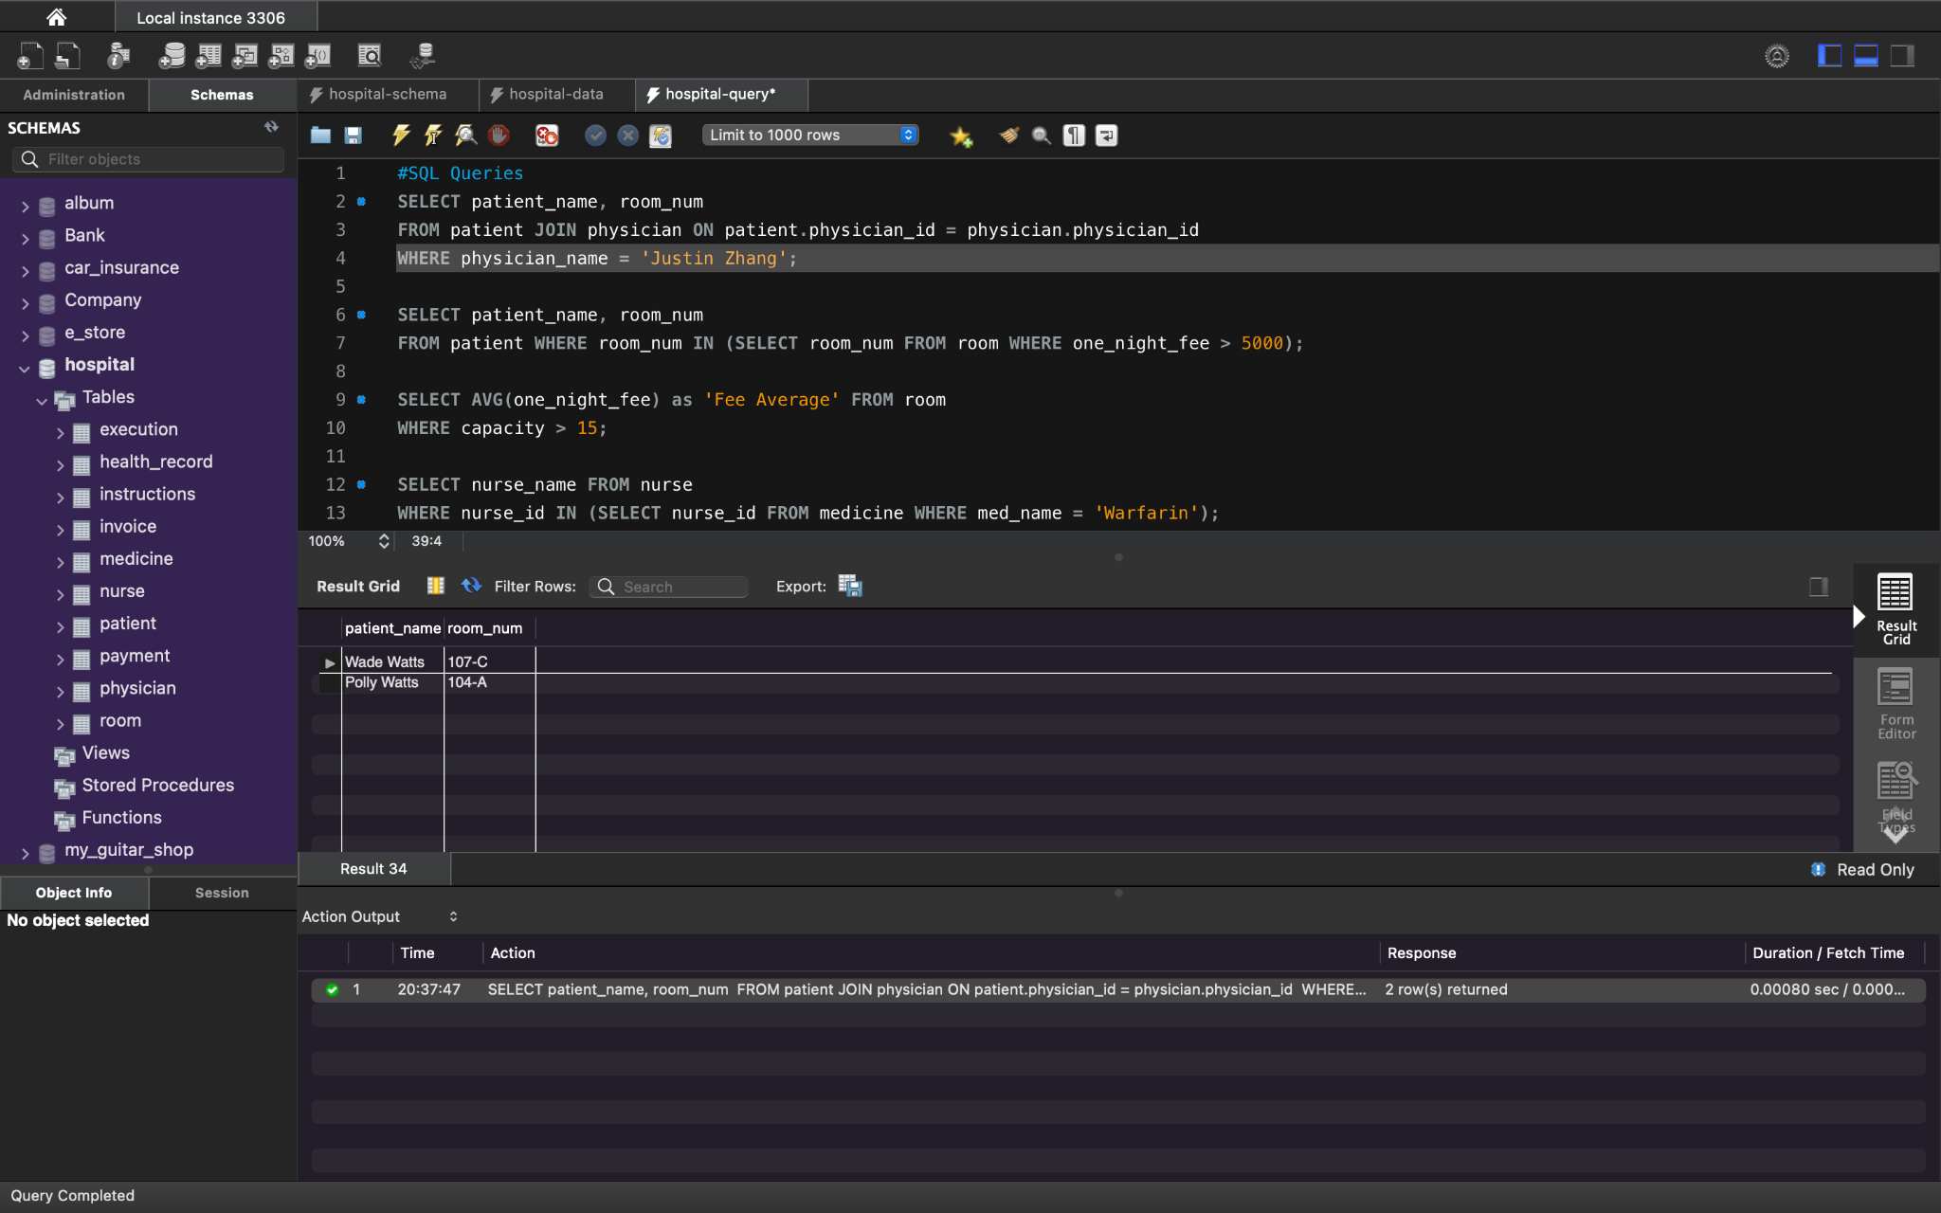

Function: Returns the patient name and room number of individuals being treated by physician Justin Zhang.

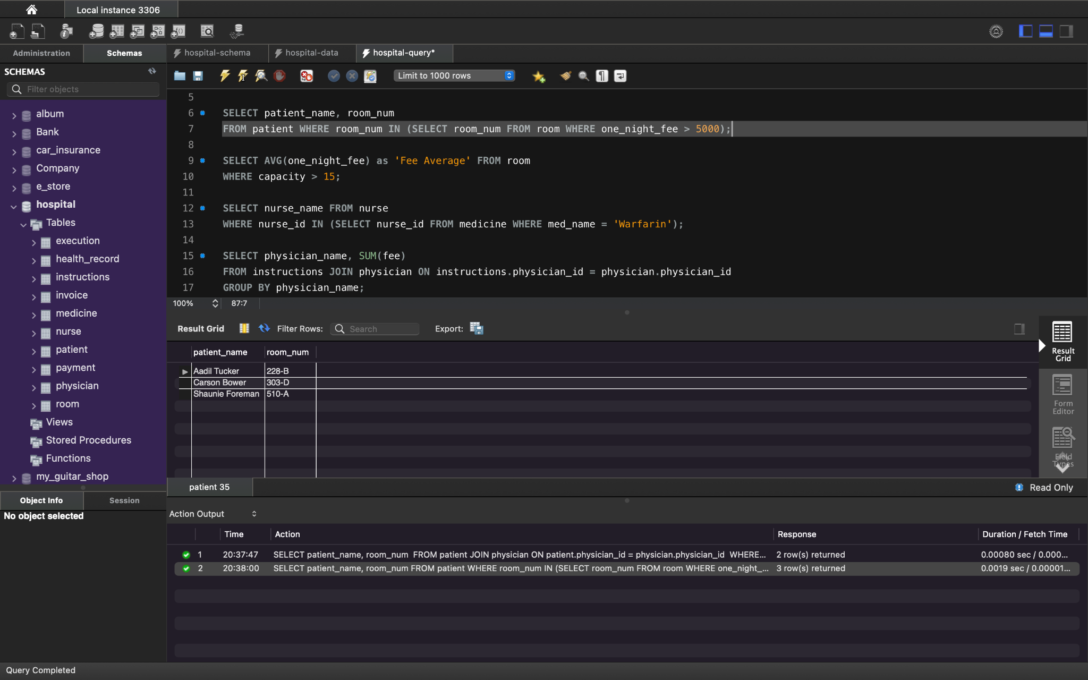

Function: Returns the patient name and room number of individuals with a one_night_fee higher than $5000.

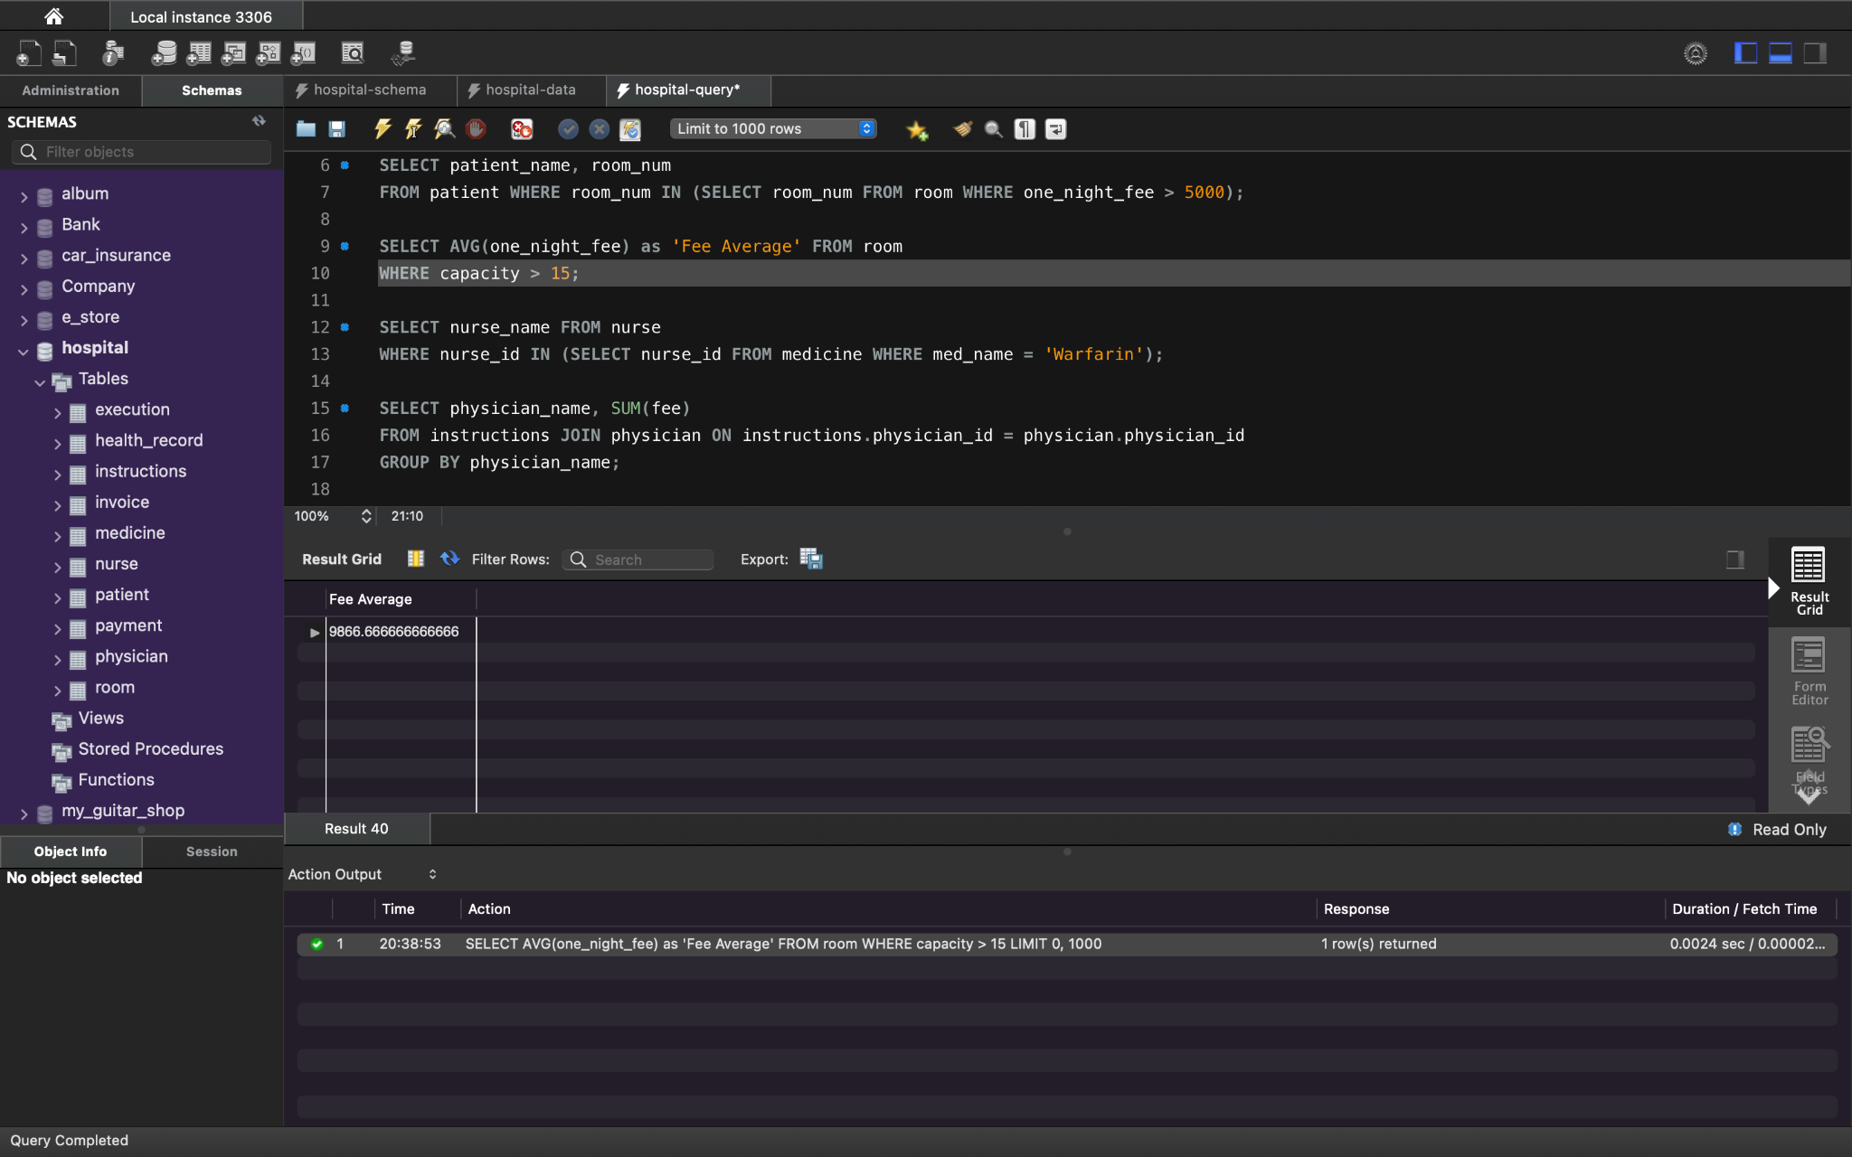

Function: Returns the average one night fee of rooms with a capacity over 15

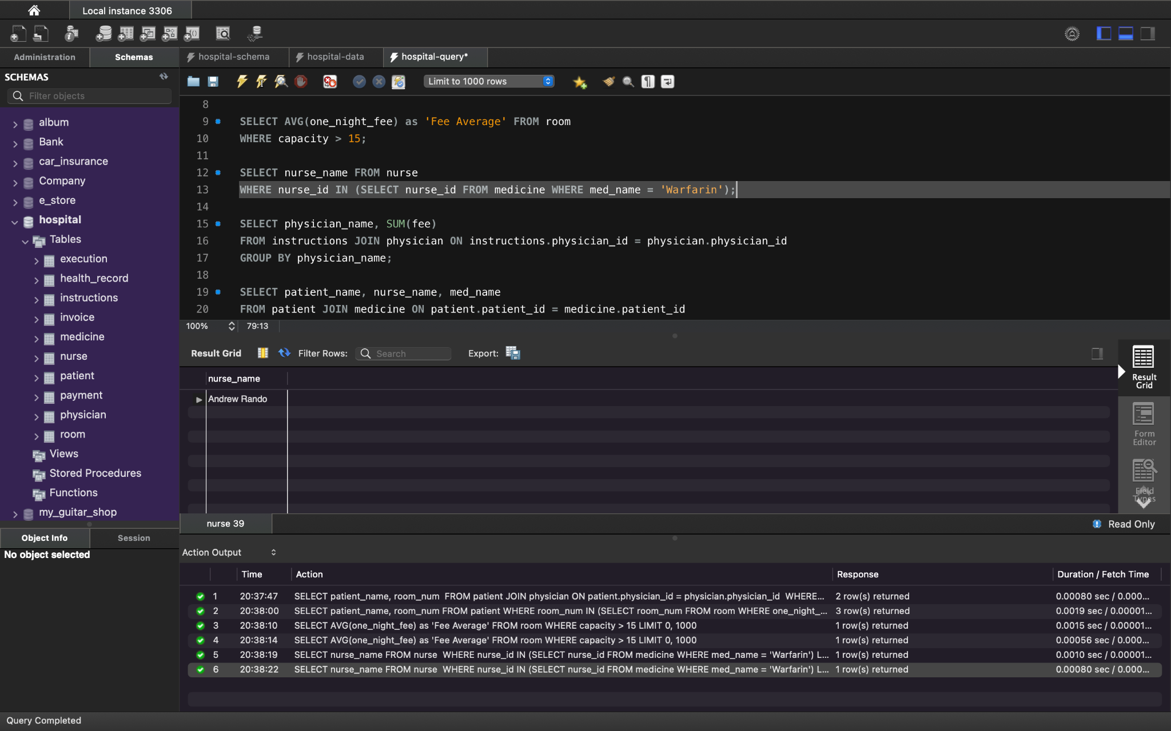

Function: Returns the name of nurses who are administering Warfarin to patients.

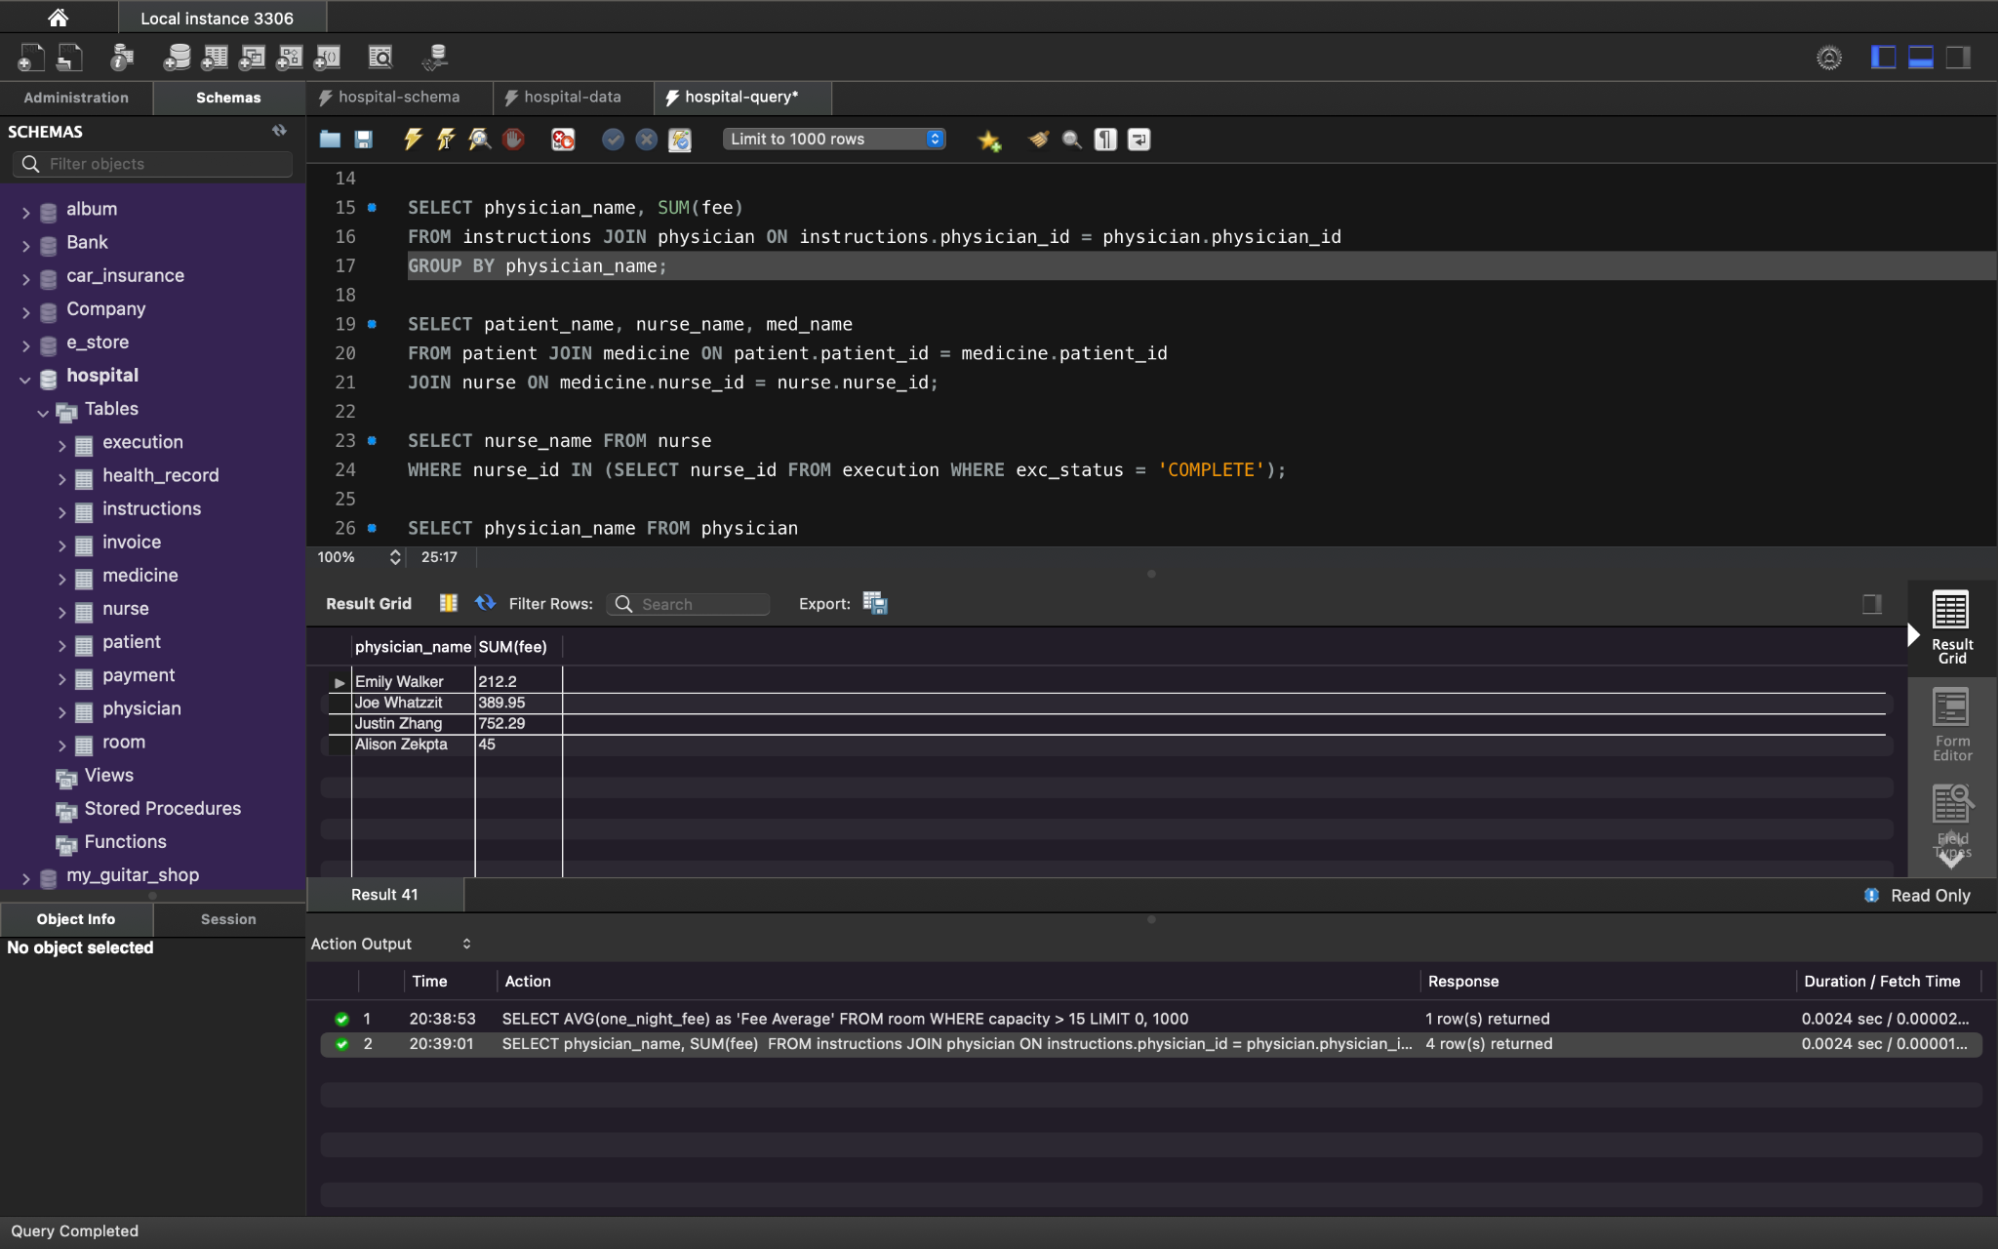

Function: Returns the total instruction fees for each individual physician

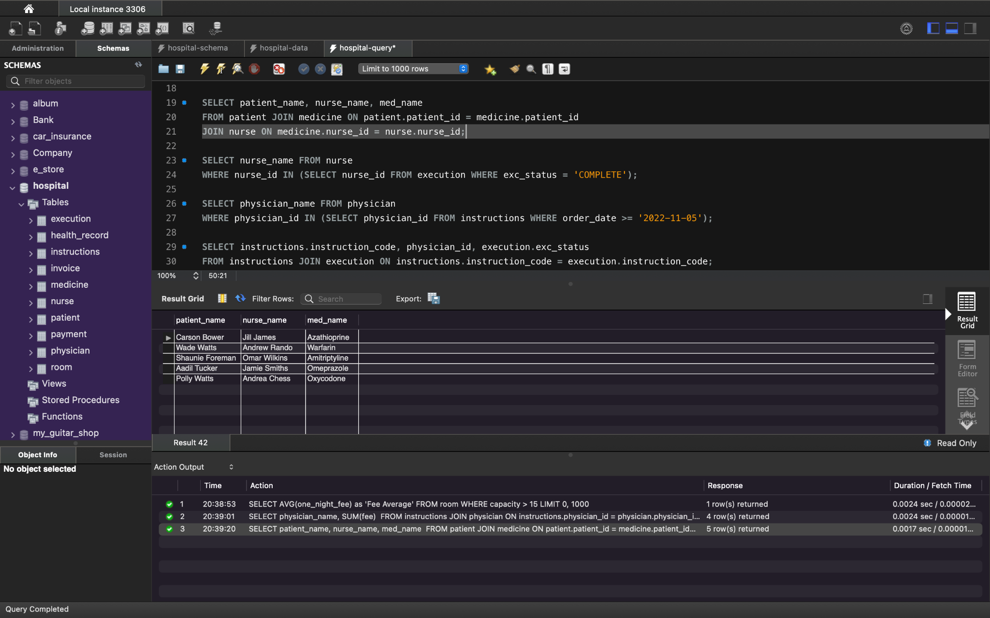

Function: Returns the name of patients, the medicine they are taking, and the nurses who are administering the medication they take.

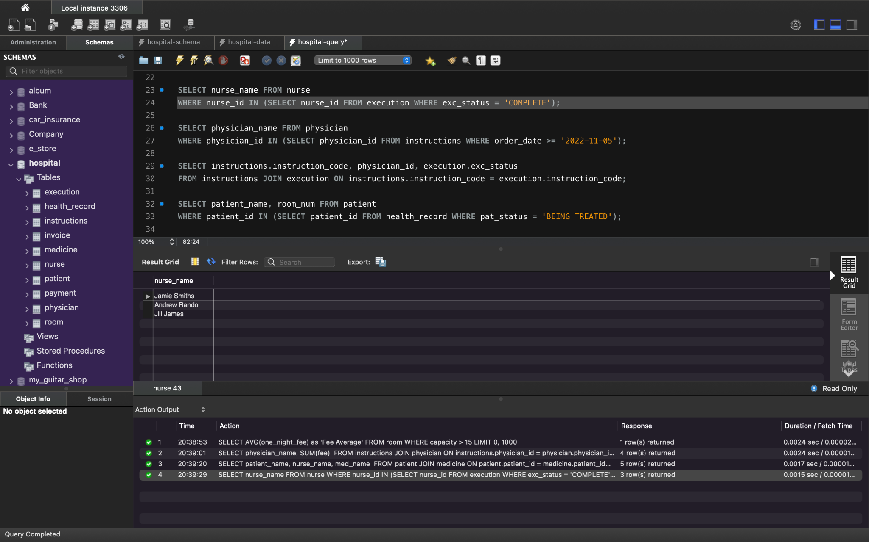

Function: Returns the name of nurses who have completed an instruction from a physician

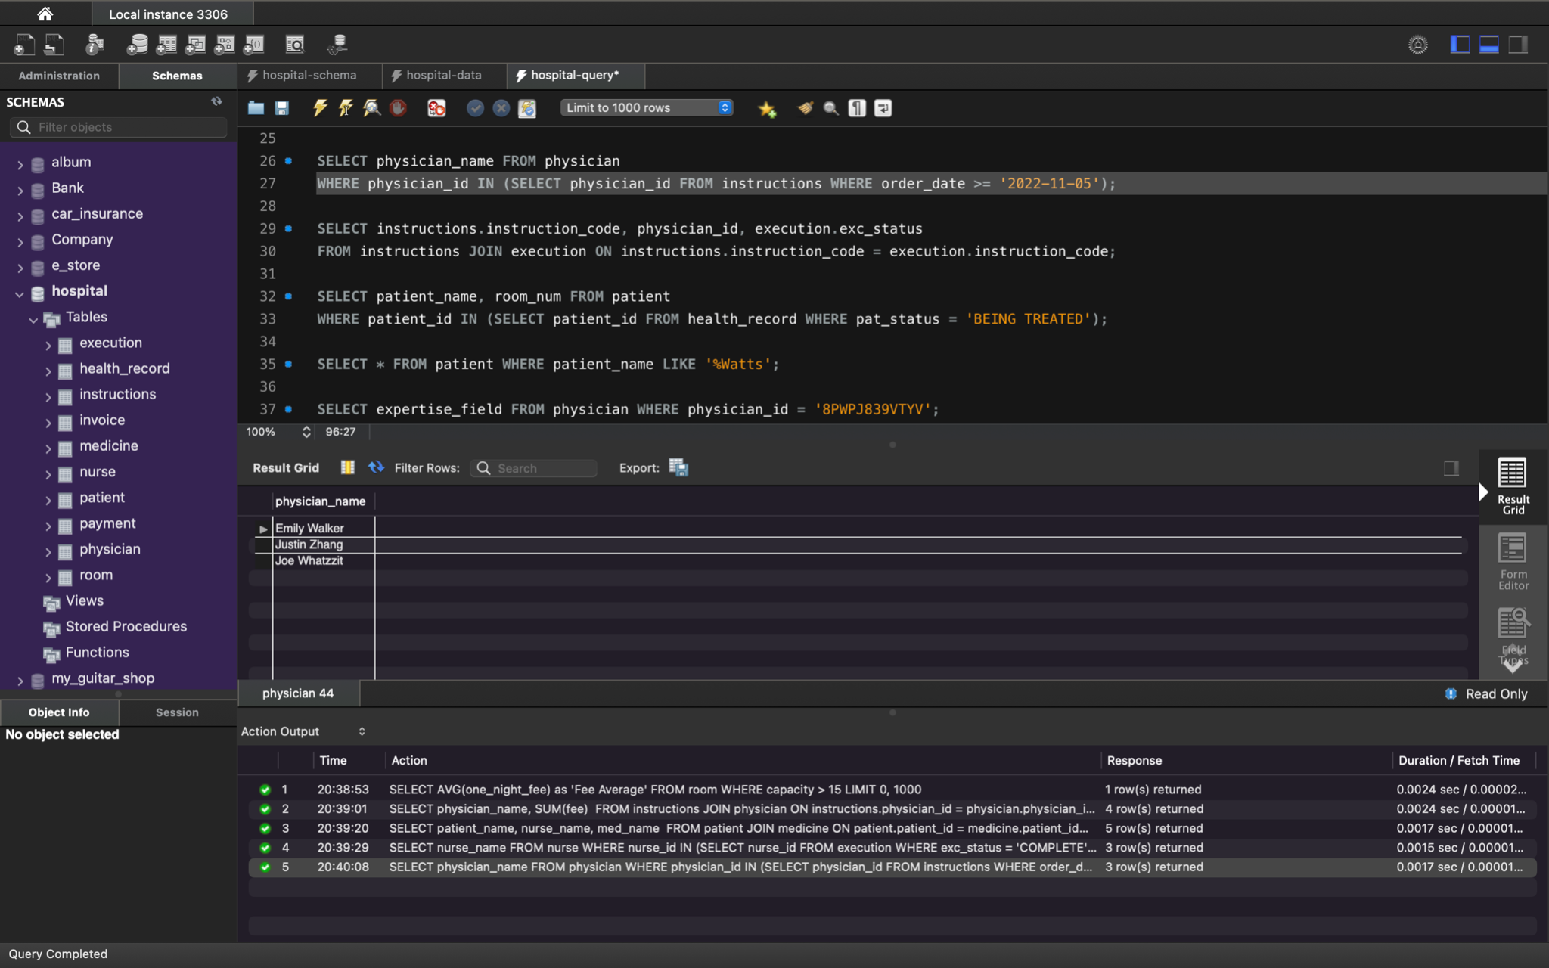

Function: Returns the name of physicians who have ordered instructions on or after 11/05/2022

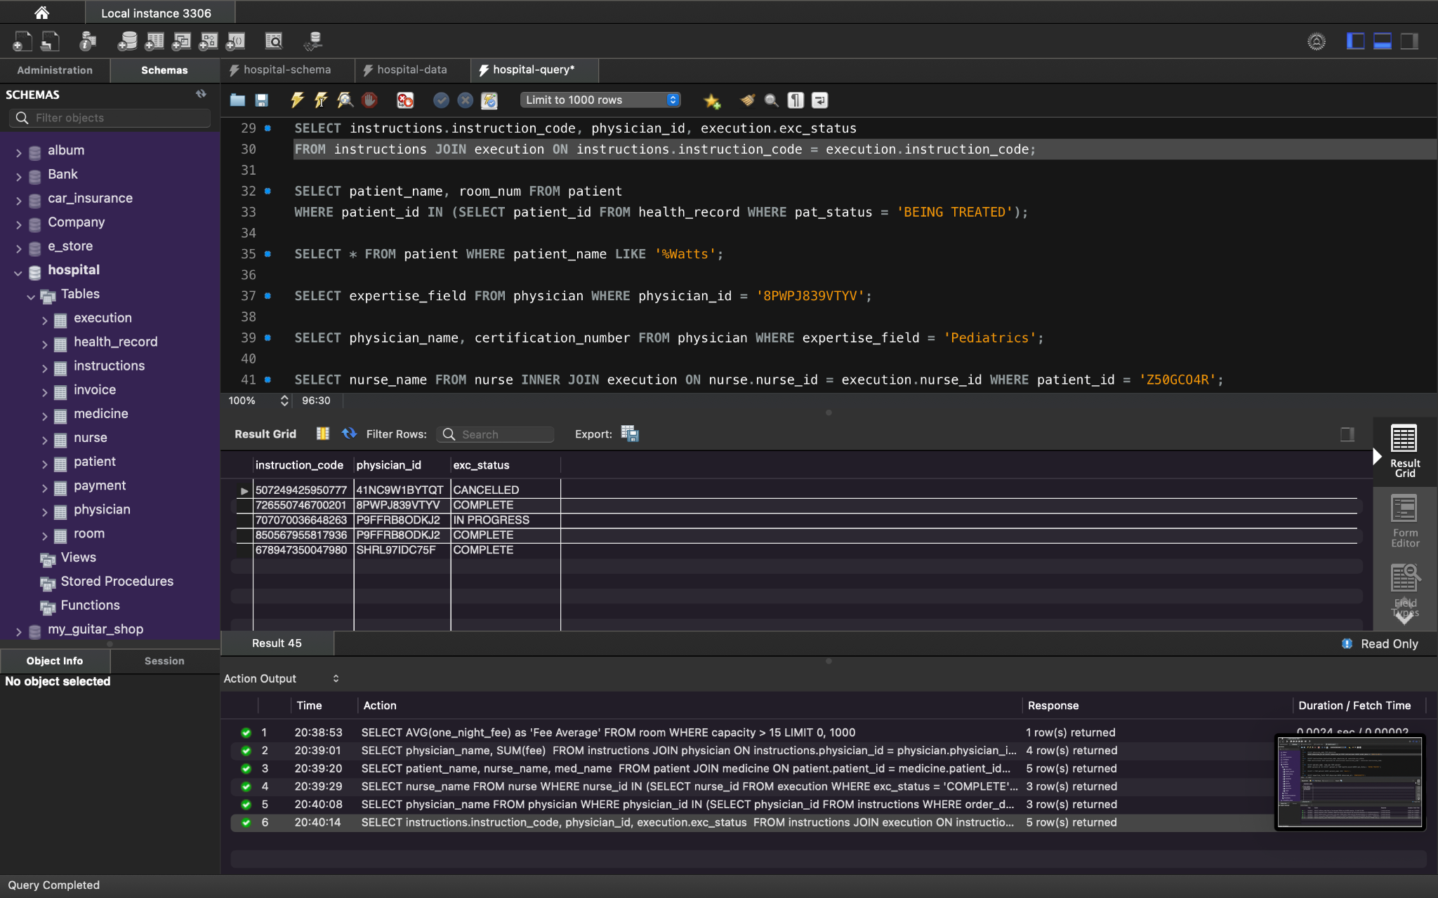

Function: Returns the physician id, instruction code, and the status of the instructions for all instructions

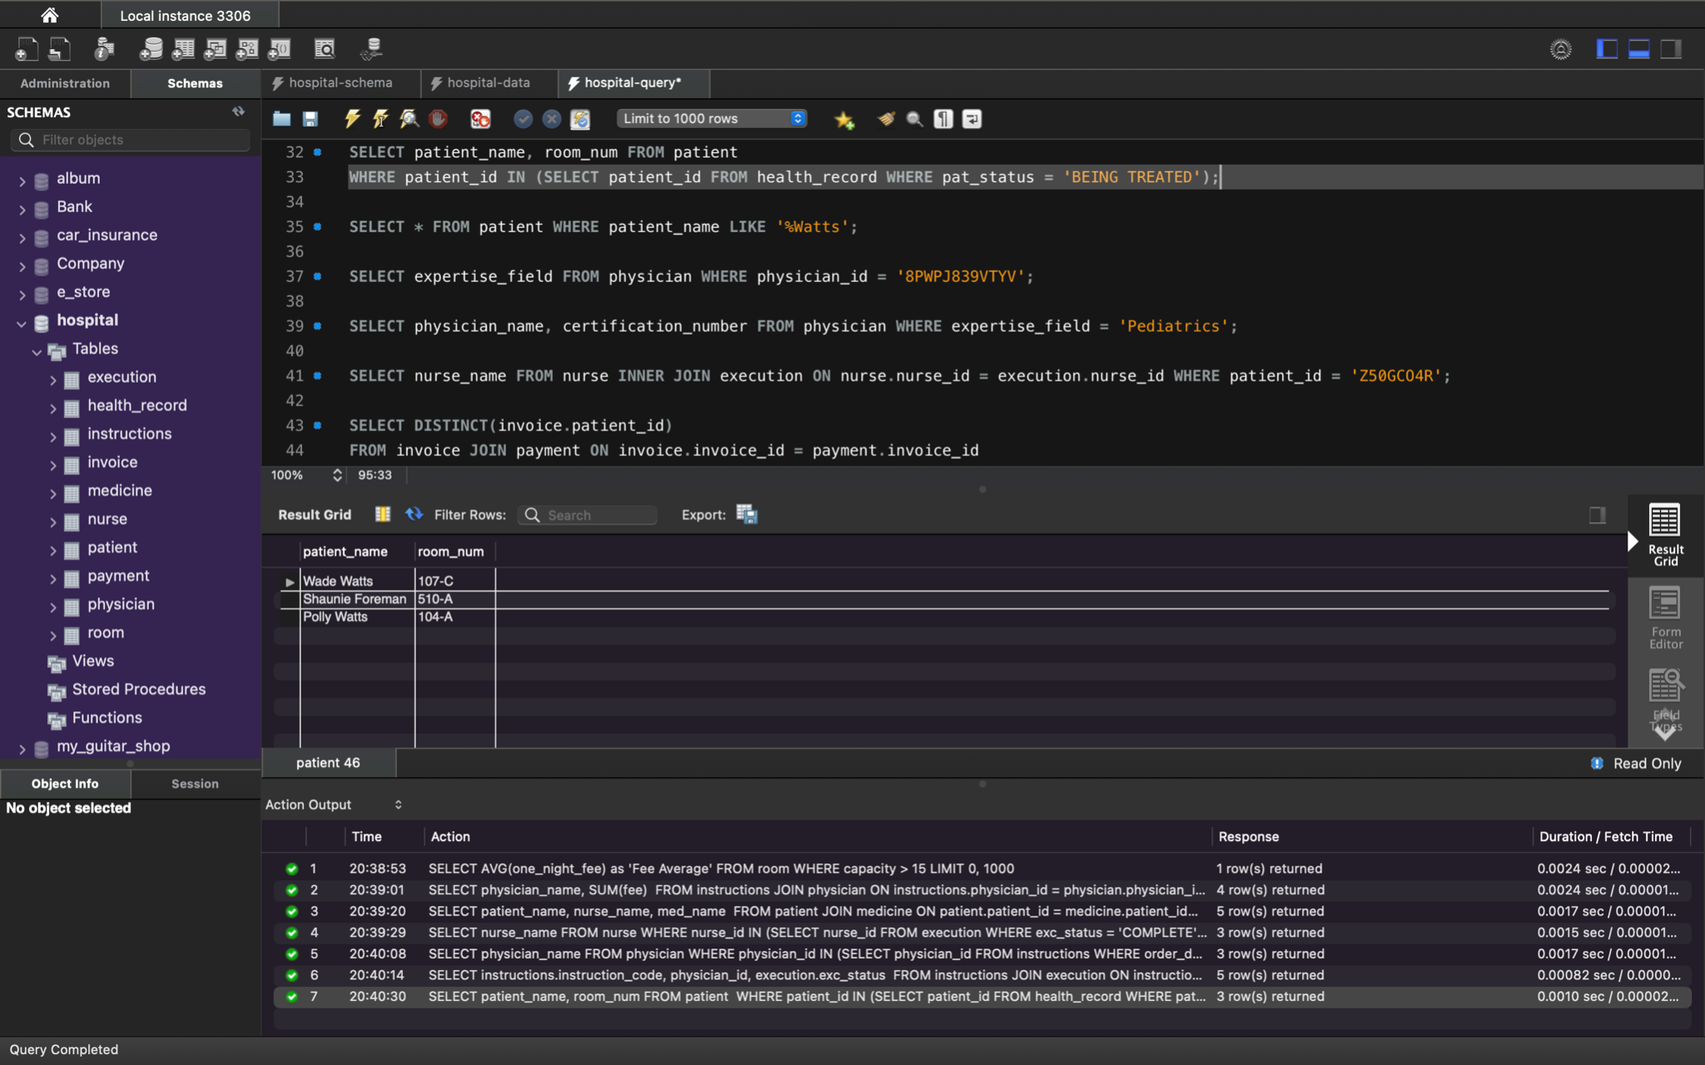

Function: Returns a list of all patients and the room numbers that are listed as being currently treated for something recorded in a health record.

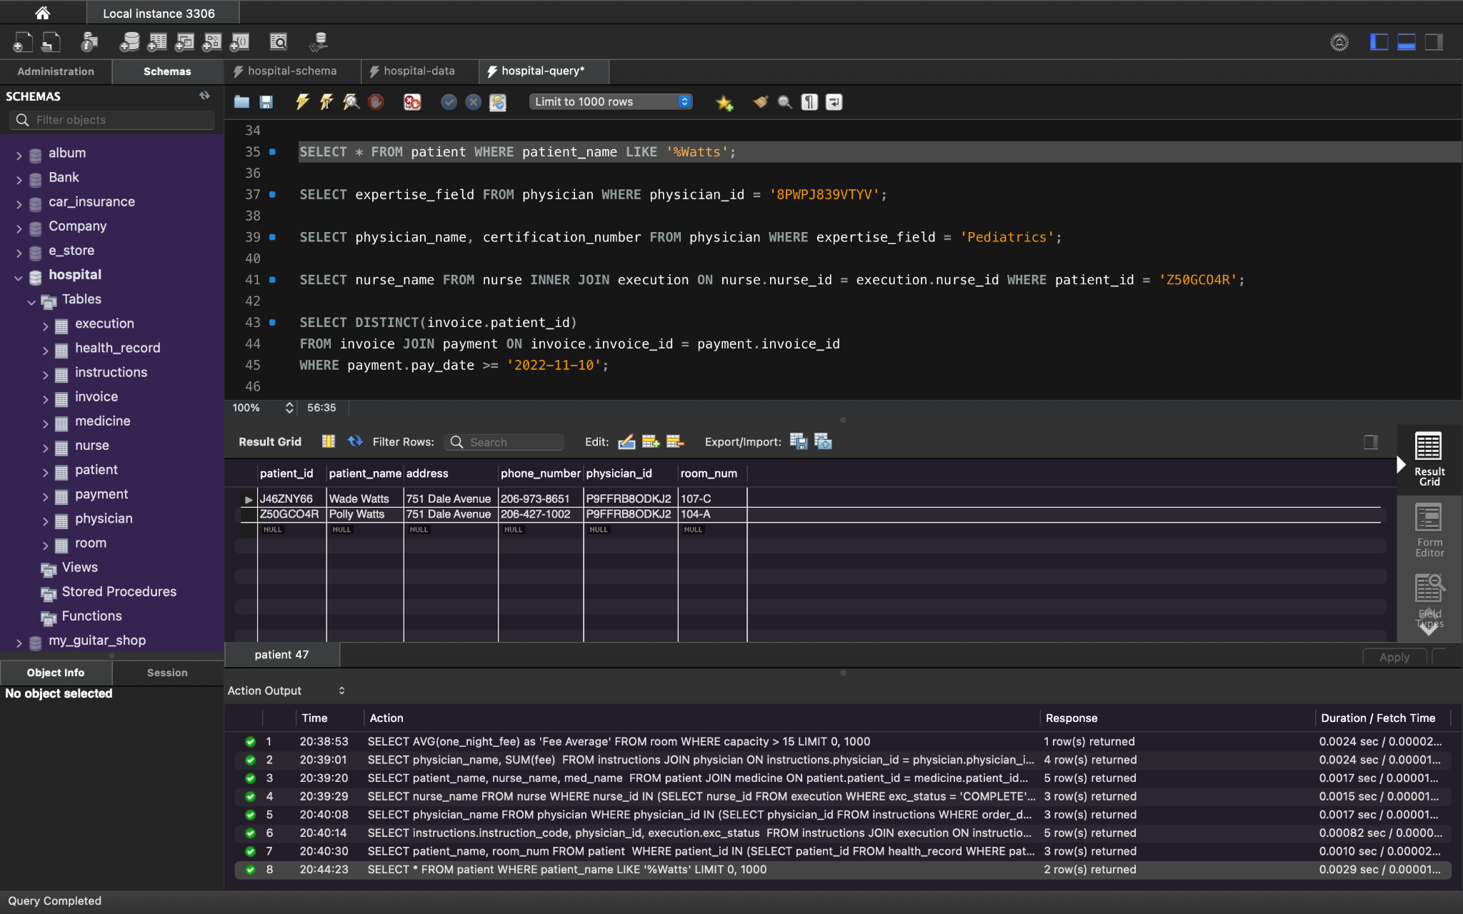

Function: Returns all patients whose last name ends with Watts

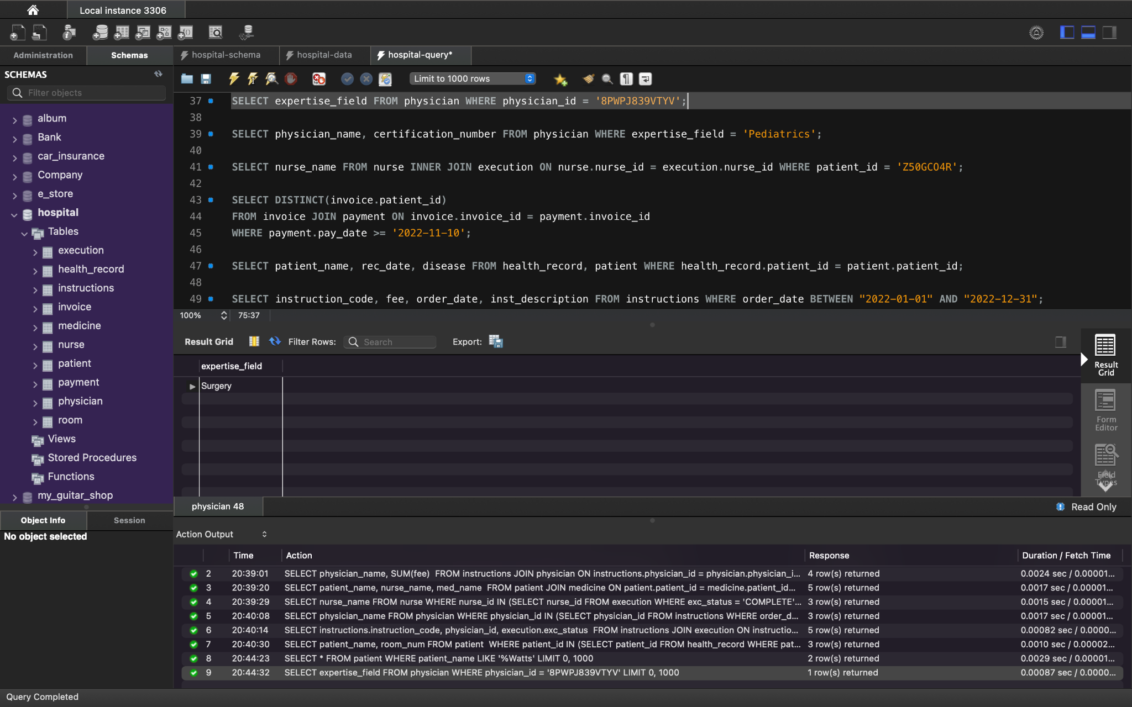

FunctionL Returns the expertise field of the physician with the ID “8PWPJ839VTYV”

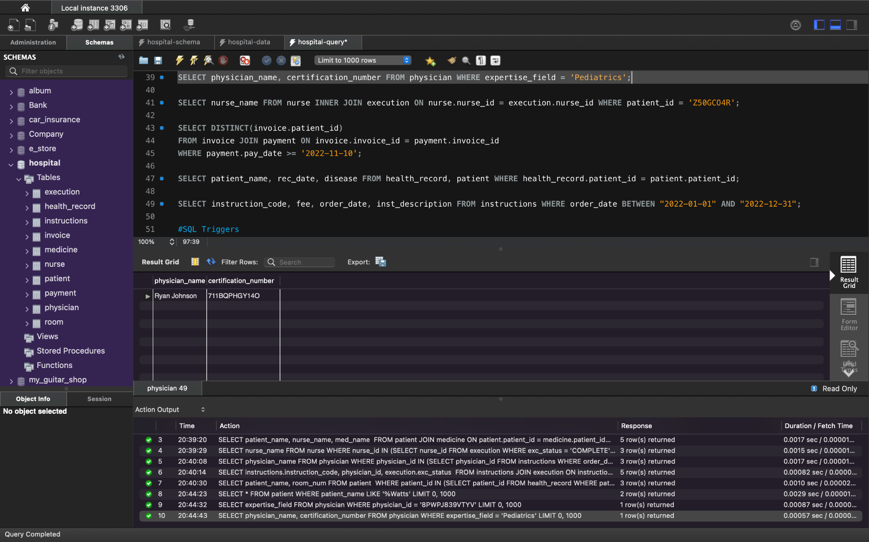

Function: Returns the names and certifications for physicians who specialize in Pediatrics.

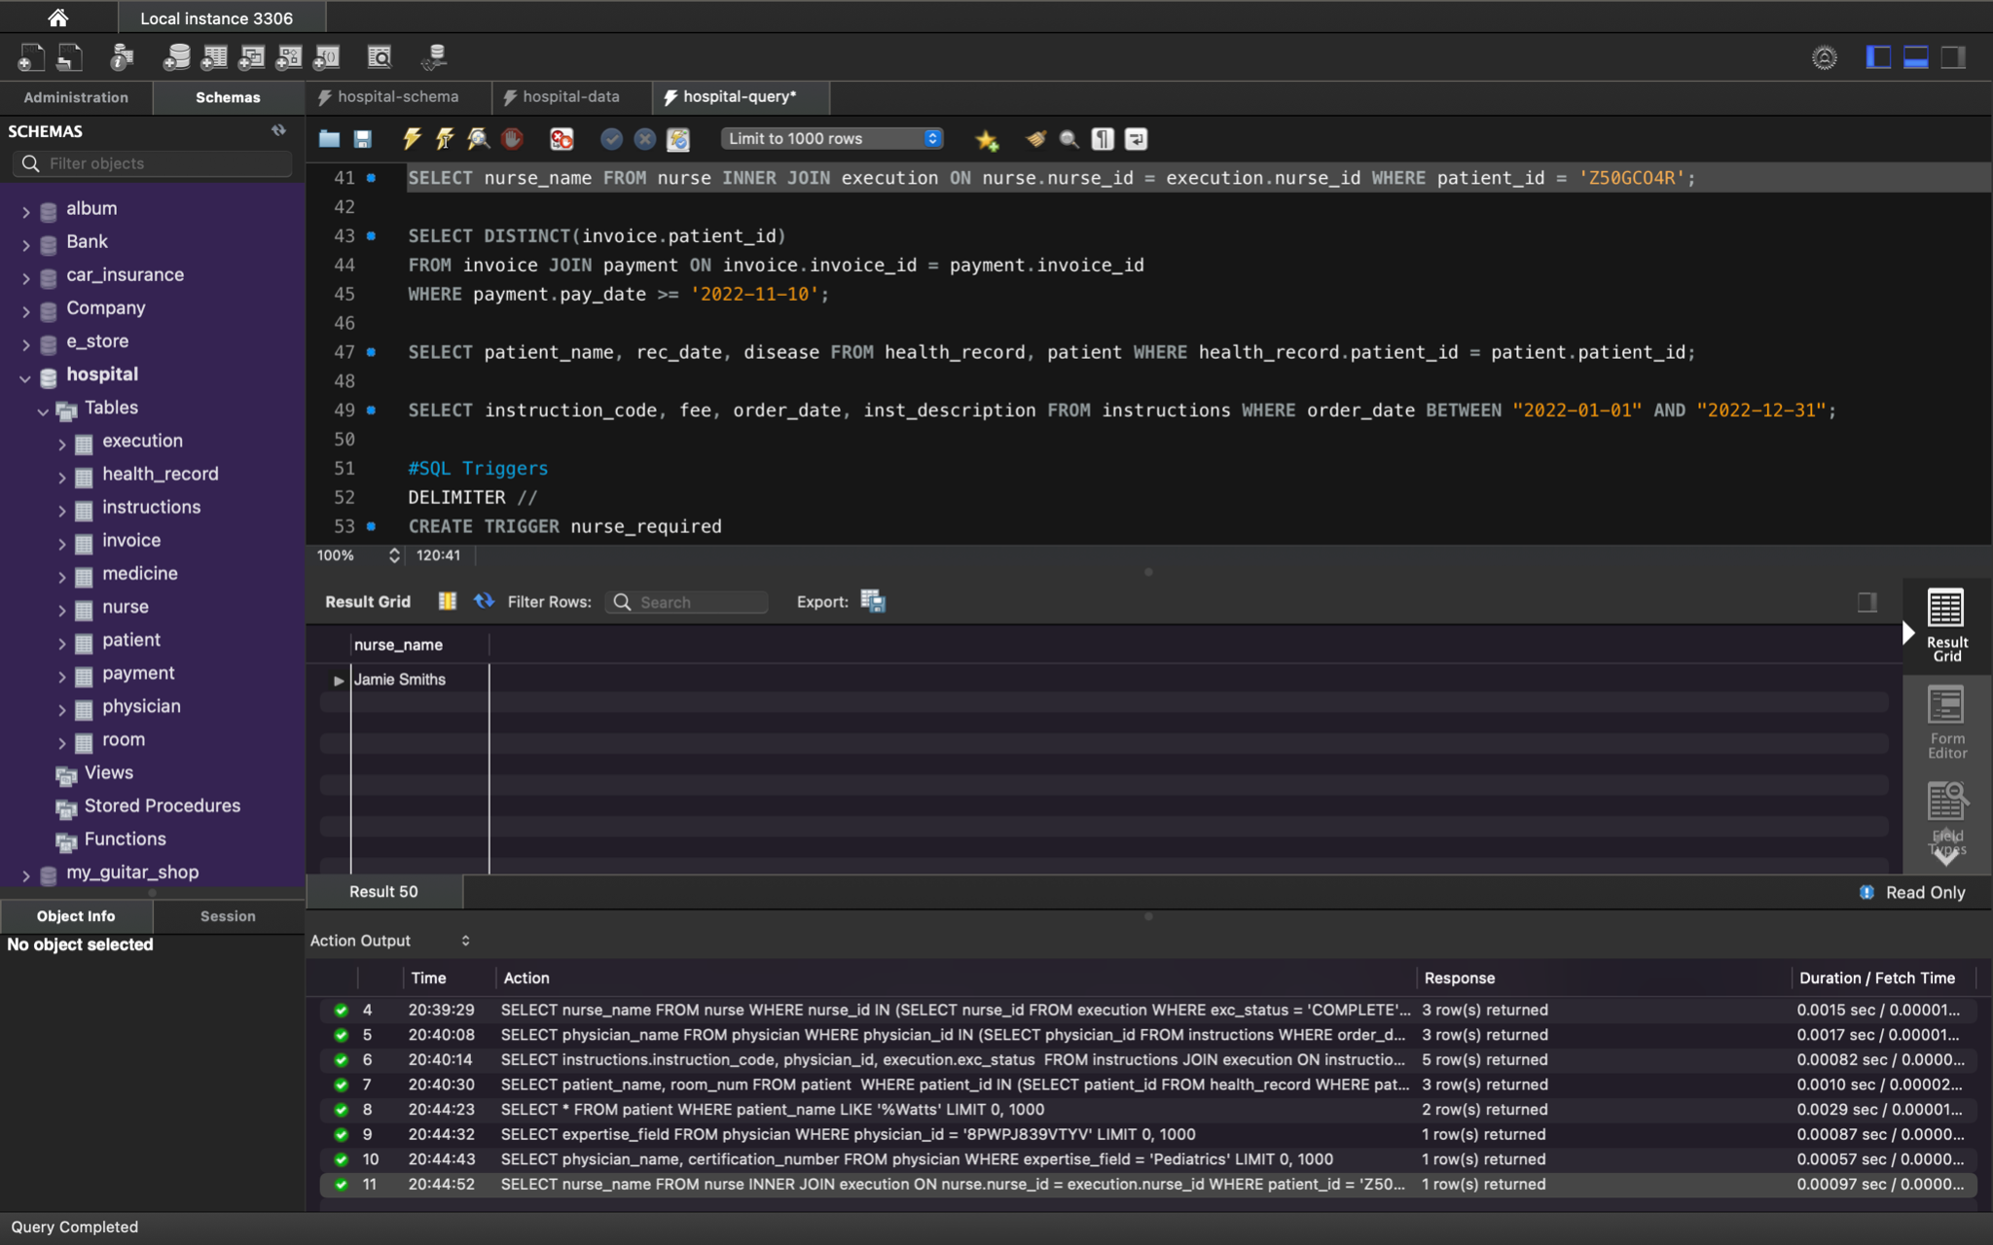

Function: Returns a list of nurse names executing physician instruction for a patient with the patiend ID of “Z50GCO4R”

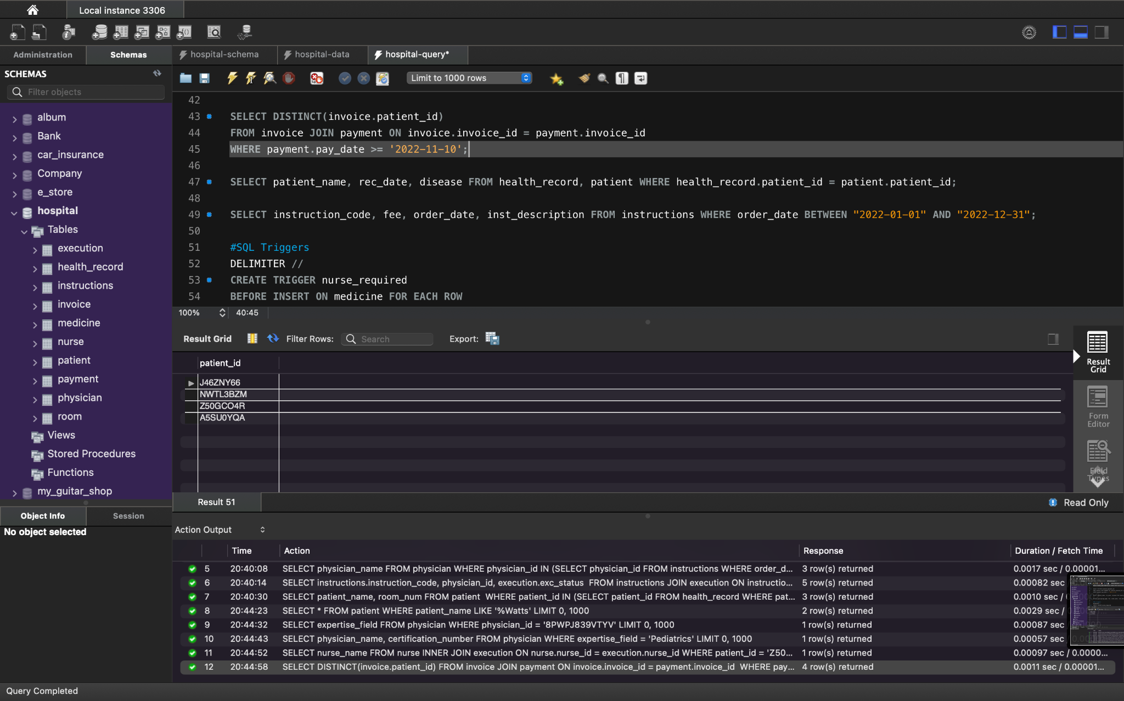

Function: Returns the distinct patient IDs of patients who have made payments towards their invoice on or after 11/10/2022

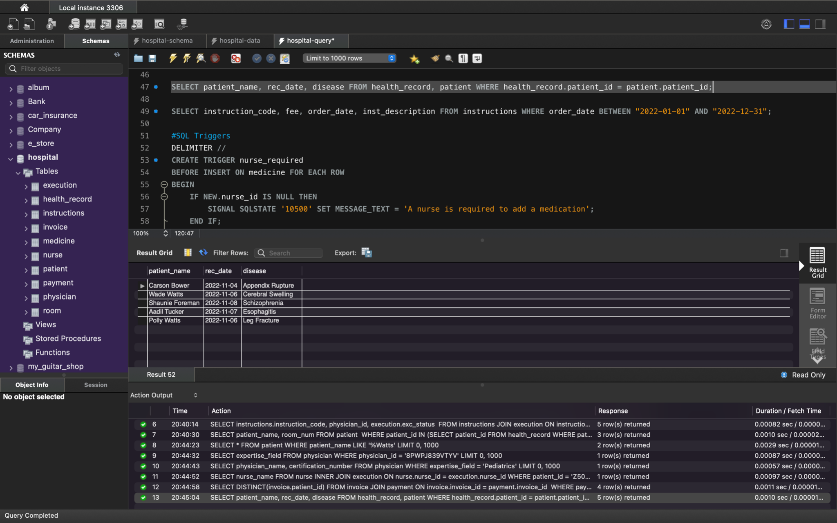

Function: Returns a patient's name, the name of the disease on their health record, and the date of diagnosis for the disease.

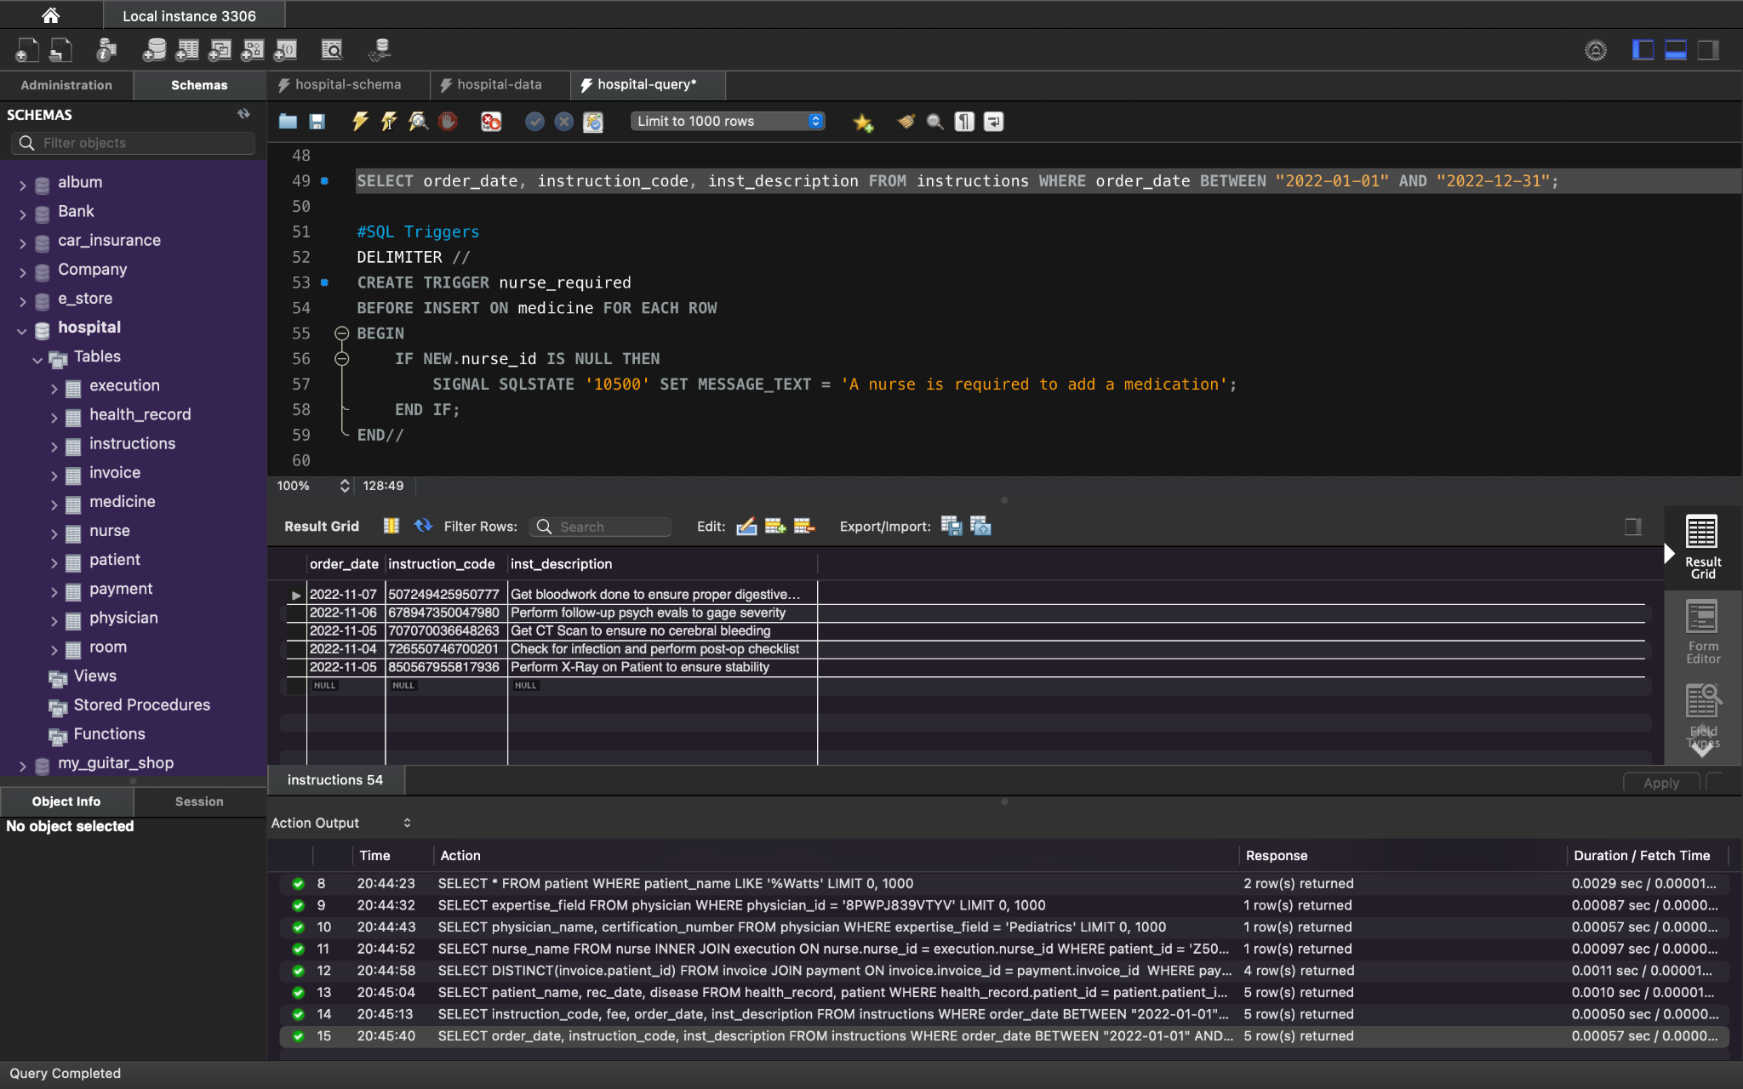Function: Returns the date, instruction code, and the description of instructions that were ordered between 01/01/2022 and 12/31/2022.